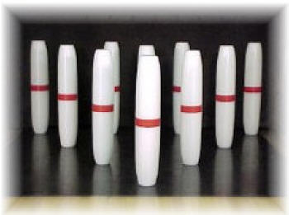
A Message from all of us at Lakeside Lanes

We are in the process of trying to figure out our fall league plans. With that being said, at this time we cannot open with full capacity with our league programs. We have decided for a limited time on some leagues, we will have to run 2 shifts, especially the evening leagues until the Governor decides we can run at 100%.
We are thinking of a 6pm shift and 8:30pm shift for those leagues that are larger. This will only be until we get the approval to run at 100%, and we appreciate your understanding with this matter.
For your safety, I have been very busy, working on the machines, lanes, approaches, worked on the men’s and lady’s room bathrooms, sanitizing each of them, installing new ceiling tiles, new vanity in the men’s room, new tiles in the lady’s room new lighting, newly painted stalls and also cleaning up as much as possible.
I am in the process of installing sanitizing stations throughout the building for your protection, and have implemented new cleaning procedures.
At this time, masks are required to enter Lakeside Lanes, you do not have to wear them while on the lane bowling, but must put them back on after you bowl, and you must wear them until you leave the building. This may change, but at this moment, this is part of the guidelines, enforced by the task force. (Lakeside will supply masks to those who need them.)
Each bowler has received this letter, (if you filled out the bowler information forms), along with your league form. Please fill this out and return as soon as possible to us. Due to the late Labor Day holiday, some leagues will be starting earlier than normal, especially Monday nights.
We look forward in greeting everyone back for a new season.
Thank you
Tim

